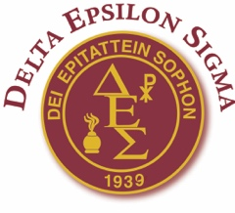 Delta Epsilon Sigma

HARRY R. KNIGHT UNDERGRADUATE/GRADUATE PRIZE FOR INTERNATIONAL SERVICE
Through the generosity of the Knight family and named for a professor and long-time member of Delta Epsilon Sigma, this award supports a student who wishes to offer service to others outside of the United States by assisting with travel costs up to $2500.00. The transformative nature of such efforts provides benefits to the student as well as to those served. New skills related to work, language, and culture can enhance résumés and refocus existing career plans. A required reflective report, submitted shortly after the student returns, will be published with photos in the Delta Epsilon Sigma Journal.
Harry R. Knight
Requirements: Applicants will submit: (1) a three-page proposal, which includes a statement of specific details of potential destination, travel costs, length of stay, assistance goals, and how the applicant’s goals correspond with the mission of DES; (2) a brief CV with biography including personal career goals, other completed service, and academic accomplishments; (3) an official transcript of coursework; and (4) a letter of recommendation which addresses the candidate’s character, academic work, and potential to contribute to society. All documents must be sent electronically to the National Office (DESNational@Neumann.edu) by March 15th.

